UML DIAGRAM-PERSONAL HEALTH AND FITNESS TRACKER

**Class Diagram UML**

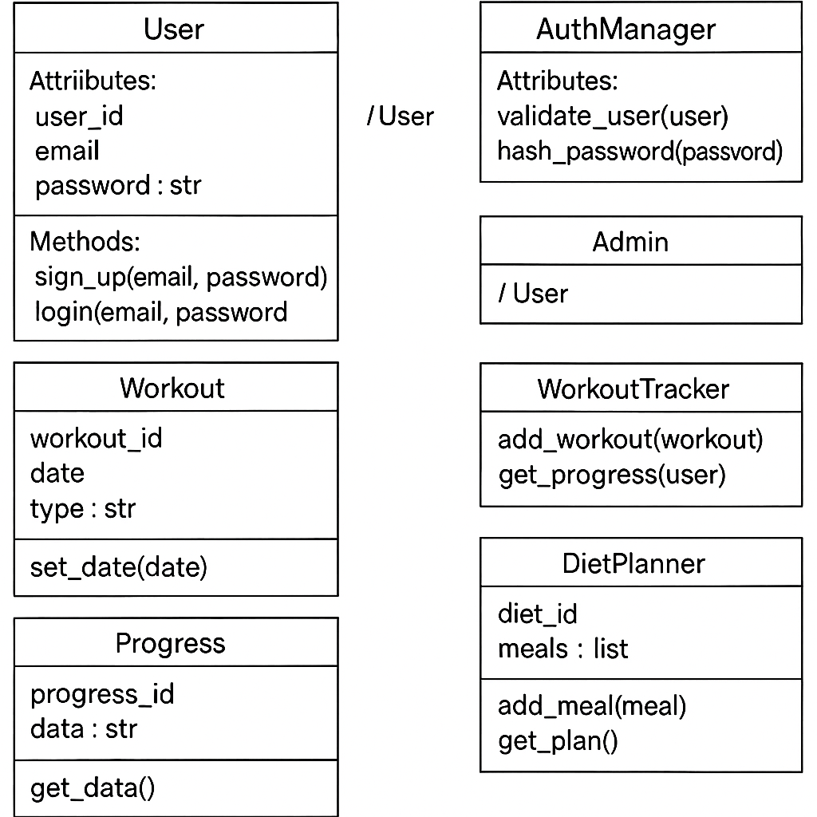

**Use Case UML**

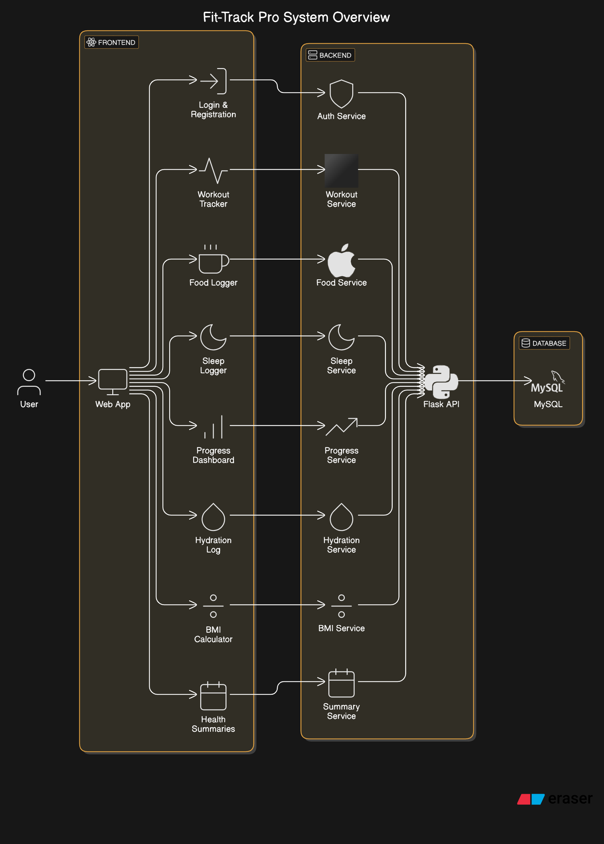

**State UML Diagram**

